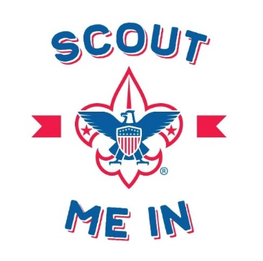
How is a troop organized?
- Scouts. In a BSA Troop, leadership comes from the scouts
  - Scouts are organized into patrols
  - Each patrol elects a Patrol Leader who will answer your scout’s questions
  - The Troop elects a Senior Patrol Leader (SPL) who is the head of the unit.
- Adults
  - The Scoutmaster (and assistants) work with the Scouts to run the program. The program includes meetings, campouts, etc.
  - The Committee is composed of registered parents to help manage the back-office business of the troop, including funds and fundraising, communication, compliance, etc. The Committee Chair is the leader of the adult support crew.
Stay in Touch:
*Discord
- Scouts use Discord for discussion and planning outside of meetings. Watch your email/phone for an invite link. Parents are welcome on the server as well.
*Scoutbook
- Scoutbook is the BSA website that handles advancement, calendar, and contact info. Look for an invite in your email. We use Scoutbook for Calendar, RSVP, Permission slips, and E-mail lists.
*Social Media
- Facebook: BSA Troop 102, Williamsburg, VA
- Instagram: troop.102
Track what do we do (and when)
- Use Scoutbook to track the Calendar
  - Add Scoutbook to your existing digital calendar- Ask Dan for help if needed
- The scouts create the long-range calendar at the Annual Planning Conference in January
- The Scoutmaster publishes the long-range calendar to parents.
How campouts work
- Check Scoutbook for calendar info and RSVP yes or no.
- Download, print, sign, and return the permission slip
- The troop will email you an invoice before the campout- send a check with the permission slip
- Parents can camp but must be registered, trained and insured with the unit
Who to ask for help?
- Scouts- ask patrol leader or SPL
- Adults- Ask the Committee Chair, Scoutmaster, or any uniformed adult
Dawn Heyse, Scoutmaster Dan Gasink, Committee Chair
troop102.williamsburg@gmail.com dcg@jgbllp.com; 757 645 8036

